**TI BYTE Simulation Exercise**

**Week 2 : RC Circuits**

* **Question 1:**

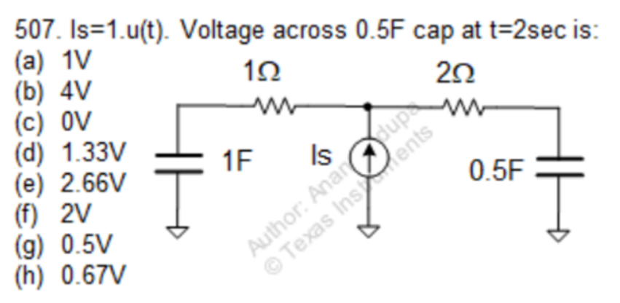

* **QUCS Circuit:**

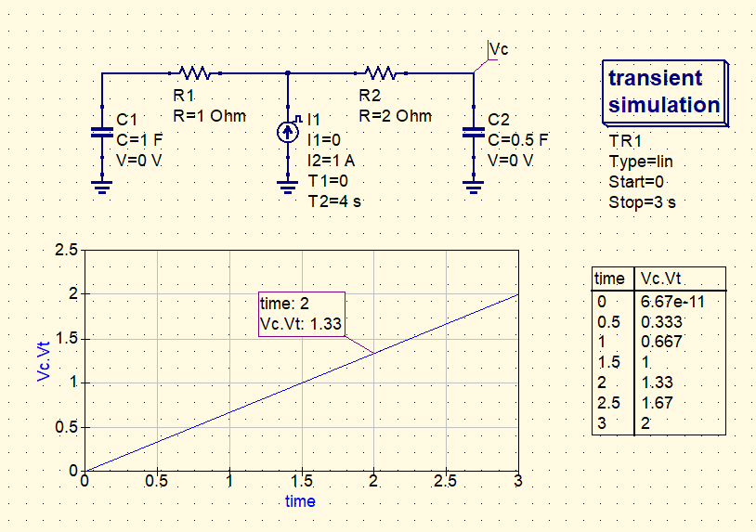

* **Vc is used to label the node and find the voltage at that node.**
* **Both the capacitors are initially uncharged, and are charged using a 1A current source.**
* **QUCS Result:**

**Therefore, from the simulation, we get our answer as:**

**Vc = 1.33V**

**Answer: (d)**

* **Conclusion:**
* **The impedance of the right-half of the circuit is twice as compared to the left half.**
* **Thus, the current gets divided in the ratio 2:1 through the 2Ω resistor and 0.5F capacitor.**
* **At t = 2s, total charge delivered to the 0.5F capacitor is**
$$Q=\frac{1}{3}×2s=\frac{2}{3}C$$

* **At t = 2s, voltage across the 0.5F capacitor is**
$$V=\frac{Q}{C}= \frac{2/3}{0.5}=1.33 V$$

* **Question 2:**

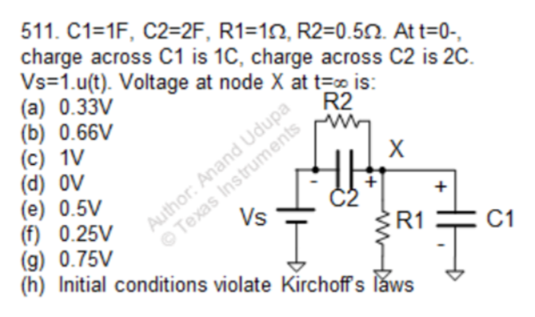

* + **QUCS Circuit:**

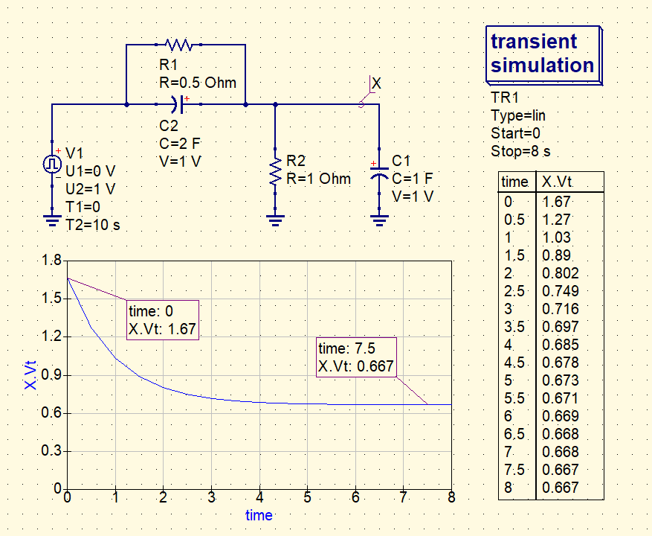

* **The node X is used to find out the resulting voltage at that node.**
* **Both the capacitors C1 and C2 are charged to 1V each.**
* **QUCS Result:**

**Therefore, from the simulation, we get our answer as:**

**Vx = 0.667V**

**Answer: (b)**

* **Conclusion:**
* **When the Vs = 1.u(t) V is given, the capacitors initially share charges.**
* **Thus, at t = 0, the voltage across C1 = 1.667 V,**

**and, voltage across C2 = 0.667 V.**

* **Now the Req and Ceq of the circuit is,**
$$R_{eq}=R_{1} \text{|| }R_{2}= 1/3Ω$$

$$C_{eq}=C_{1}+ C_{2}= 3 F$$

* **Thus, the time constant of the circuit,**
$$τ=R_{eq}\text{×}C_{eq}=1 s$$

* **When the circuit reaches a stable state, the capacitors act as open circuit.**
* **The final voltage at X = $\frac{R_{1}}{R_{1}+ R_{2}}$ = $\frac{1}{1.5}$ = 0.667 V**